THIS IS A FICTIONAL EXEMPLARY ABSTRACT:
A GUIDE TO WRITING IN THIS TEMPLATE

Silvia Greenwood¹, Peter Rock², Sienna Clay³

¹The Institute of Perpetual Mud Studies; Bogmoorcity, The Republic of Terra Granulosa
²The Academy of Earthly Intricacies; Crumbleton, The Grand Kingdom of Silicius
³The Bureau of Unstable Soil and General Mess; Muddletown, The United Federation of Pedovadia

Corresponding author:silvia.greenwood@ipms.terragranulosa.re

ABSTRACT
Soil is often taken for granted, yet recent research suggests that it harbors a previously unrecognized yet essential component: Soil Tolerance (ST). This elusive substance, which appears to be a fundamental aspect of soil resilience, has been steadily diminishing. The aim of this study was to isolate, quantify, and characterize ST across multiple soil types and assess its ecological implications.
Extensive fieldwork was conducted in diverse pedological zones, ranging from the Vertisolic Wastes of Upper Bogmoor to the Loessic Highlands of Siltbury. The research team employed advanced methodological approaches, including nano-granulometry, inverse pedochromatography, and the highly experimental Subterranean Oscillatory Liquefaction Evaluation (SOLE) protocol. Samples were analyzed using a custom-built GeoSpectroHyperAnalyzer 2025, which, despite frequent malfunctions and occasional small explosions, provided unprecedented insights into the microstructure of ST.
Key findings indicate that ST exists as a complex lattice of physicochemical interactions, binding soil particles in a manner reminiscent of both electrostatic cohesion and mild existential dread.

Table 1: Land quality and activity compatibility
Soil Texture | Population  [worms/m³] | Temperature  [ºC] | Index of Suitability  [%]
Loamy | 500.0 | 20.2 | 50% for picnics50% for yoga
Sandy | 0.0 | 30.3 | 100% for sunbathing
Clay | 50.0 | 17.7 | 100% for mud wrestling
Rocky | 0.0 | 28.8 | 0% for digging

Alarmingly, our data reveal a 36% decline in ST concentrations over the past decade, particularly in areas with intensive agriculture and bureaucratic oversighttoward producers. PCA analysis identified two key factors: the earthworms’ arrogant response to intensive tillage, explaining 62% of the variance (PC1), and the passive-aggressive behavior exhibited by plants grown in monoculture, explaining 28% (PC2).
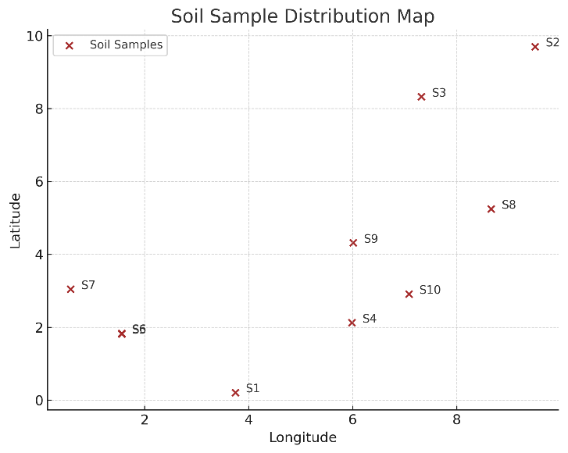
Chart 1. A love story of data – from chaos to clarity

We conclude that Soil Tolerance depletion poses a significant risk to long-term soil stability, necessitating urgent conservation efforts. Proposed mitigation strategies include controlled applications of life-infused compost, ritual appeasement of subsoil deities, and the reintroduction of long-forgotten agroecological wisdom.
Further research is required to determine whether ST can be artificially synthesized or if humanity must simply learn to be nicer to its soils.

Key words: soil tolerance, pedochromatography, subterranean oscillations, agroecological wisdom

ACKNOWLEDGMENT
We would like to thank the soil for putting up with us all these years, and our field assistants for not getting lost in the fields.

ORCID
Silvia Greenwood [https://orcid.org/1234-1234-1234-1234]
Peter Rock [https://orcid.org/1234-1234-1234-1234]
Sienna Clay [https://orcid.org/1234-1234-1234-1234]

