Please return the completed form to the email address ana.katic@frusketerme.comfor the reservation.

HotelMovenpickResort&SpaFruškeTerme4*20.10-24.10.2025.
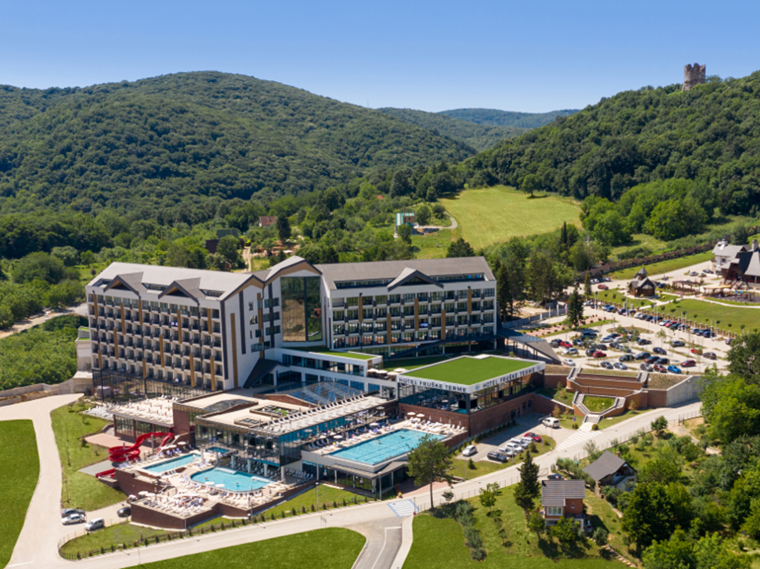

Kindly complete the following details for each person (even if there are two guests in a double room). Reservations will only be accepted using this form:

Booking request date:
Name:
Surname:
City:
State:
E – mail:
Phone number:
Check-in date: | dd/10/2025
Check-out date: | dd/10/2025
Single room (accommodation for one person): | ☐
Double room (accommodation for two people):  Name of your roommate: | ☐

Hotel Movenpick Resort & Spa Fruške Terme 4* 20.10-24.10.2025.
Bed and breakfast - 120.00 EUR in a single room, per night
Bed and breakfast - 80.00 EUR in a double room, per person per night
City tax: 110.00 RSD per person, per night
*The price in RSD depends on the Central NBS exchange rate on the date of the tax liability

The package includes:
*Check in at 2 p.m., check out at 11 a.m
*Accommodation based on the selected service
*The water world of the Fruške terme hotel
*Sauna world of the Fruške terme hotel
*Non-alcoholic mini bar + coffee machine in the room
*Parking

100% advance payment is required to confirm the reservation.
If you want the payment to be made through the company's account, it is necessary to submit the company's ID information.

If you need a transfer service from the airport to the hotel, or a transfer service from the hotel to the airport, please send us the transfer request when sending the reservation form to the email address for booking accommodation.

Accommodation can be booked no later than August 15, 2025.
For reservations after the specified date, the hotel does not guarantee the price and availability.
Cancellation policy: 14 days before arrival the hotel keeps 50% of the paid funds, 7 days before arrival the hotel keeps 100% of the paid funds.
We wish you a pleasant stay!

Address for reservations: ana.katic@frusketerme.com

Phone number: +381 2221 55 260
+ 391 63352414

